Level-3 Organometallics L6b
Alkene complexes - Dewar/Chatt/Duncanson model
(b) bond angles
When backbonding occurs, hybridisation of alkene C- atoms changes from sp² to approaching sp³. This has an implication for the bond angles (sp² C-atom is planar sp³ C-atom is pyramidal)

So - substituents "bend-back" from the metal - the greater the
π-donation the greater the bend-back.

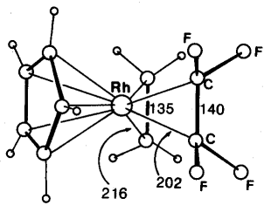
C-C distances C₂H₄ = 1.35 Å
C₂F₄ = 1.40 Å
Rh-C distances C₂H₄ = 2.16 Å
C₂F₄ = 2.02 Å
More π-donation in C₂F₄ ligand because F atoms are electron withdrawing.
CpRh(C₂H₄)(C₂F₄)
"Bend-back" angle C₂H₄ = 17º C₂F₄ = 37º
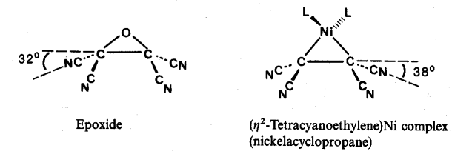

Alkene complexes can also be thought of as metallacyclopropanes
Two approaches are complementary.

